Brief overview of session purpose and content of module. | Logistics
This session explores responsive teaching (RT) through an FE Maths lens.  Participants will explore the concept of RT and what it means to them, forensically examine a topic common to both FS and GCSE, and then design diagnostic questions in a variety of forms which can be used in their classrooms.  The session will draw upon participants’ own experience, the research from Centres and wider literature.  The PRE-SESSION task for this module is to read a CfEM blog about Responsive Teaching: https://www.et-foundation.co.uk/cfem/diagnostic-responsive-maths-teaching/ | Room Layout  - Cabaret style  - Projector with accessible PC and/or laptop connection (with internet)  - Drywipe board  Materials Needed  - Flipchart sized paper  - Marker pens  - Sticky putty  - Normal stationery (sticky notes, notepaper, pens)  Mentimeter  A menti question will need setting up by the PD lead. See slide 9.  https://www.mentimeter.com/  Course webpage  Course resources can be accessed from the CPD pages of the CfEM resources and evidence hub: https://www.et-foundation.co.uk/professional-development/maths-and-english/cfem/cfem-resources-and-evidence/cfem-professional-development/modular-course/  PowerPoint  Slides with yellow banners should be personalised by the PD Lead for their session and location. The yellow banners should then be removed.  Suggestion  Ask participants to bring internet enabled laptops or tablets. Arrange with the venue for wifi logins so that participants can access and explore the Padlet.

Time for session: 3 hours

Module 2 - Resource list and printing requirements
Notes:
- Updated files should have the date in their filenames. Each time you lead a module, check that you are using the latest resources. File content will be regularly reviewed and improved.
- Resources are numbered for ease of reference. First number is module number, second number is resource number. Resources are in no particular order.
- Check that all files and links will open and run on the computer you will be using when you lead a session. PowerPoint doesn't always work well if run on a version different from the one it was written in..

Resource number | Filename | Section in which it is used | Number to print | Printing essential, suggested or e-version only?
2.1 | 2.1 Module 2 Presentation | All | A4, colour, handouts, stapled in top left hand corner, 1 per participant | Essential
2.2 | 2.2 Module 2 Session Outline | All | A4, B&W, stapled in top left hand corner, 1 per PD leader/trainer | Suggested
2.3 | 2.3 Module 2 Reflective Log | All | A4, B&W, 1 per participant | Suggested
2.4 | 2.4 RT Quotations | 3 | A4, B&W, 1 per participant | Essential
2.5 | 2.5 Question Matrix | 5&6 | A4, B&W, 1 per participant | Essential
2.6 | 2.6 LSC Question Examples A | 5&6 | A4, B&W, 1 per participant | Essential
2.7 | 2.7 LSC Question Examples B | 5&6 | A4, B&W, 1 per participant | Essential

Time  (Elapsed time in brackets) | Slide number | Learning intention | Slide notes and additional information
Pre-session task | On Module 1 Padlet | Aim: To pique participants’ interesting in Responsive Teaching prior to the session. | Make sure that teachers have the pre-course tasks at least a week before Module 2.
 | 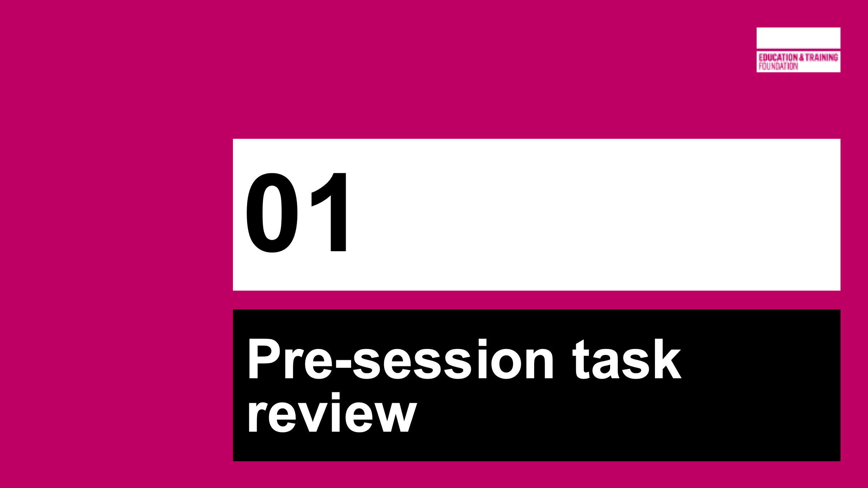 | SECTION 1  PRE-SESSION TASK REVIEW
10 mins  (10) | Slide 3 | Aim: To get participants talking to each other about Responsive Teaching (RT) and reflect on their pre-session task collectively | Reflect on ETF blog post.  On tables – What did you notice? What do you wonder? What are your opinions?
 |  | SECTION 2  AIMS AND SCHEDULE
5 mins  (15) | Slides 5-8 | Aim: To share module aims and housekeeping information. | Resource 2.3 – Reflective log - somewhere to make brief notes about items they can take away and use.  Also highlight the course Padlet as a hub for all resources from the modules.  Slides 6&8 – populate with information for this local session.
 | 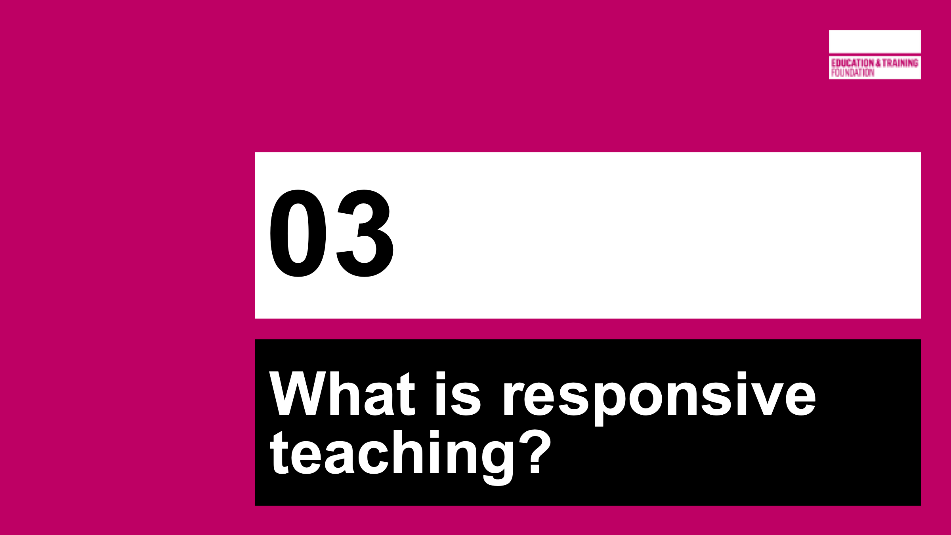 | SECTION 3  WHAT IS RESPONSIVE TEACHING?
10 mins  (25) | Slide 10 | Aim: To collate participants’ thoughts and understandings before comparing and triangulating with Centre Leads’ thoughts and literature | Gathering of thoughts and understandings before comparison with Centres and Literature.  PD Lead will need to create own Mentimeter poll for this section.  Feedback to the participants, using the word cloud function.
5 mins  (30) | Slide 11 | Aim: To explore the second part of the triangulation – Centre leads. | This slide represents an overview of Centre Lead’s thoughts about responsive teaching. They were asked to suggest 3 words or short phrases to describe RT.  Slide animates the thoughts, one by one.  The three larger comments are most interesting, especially the addition of the word USEFULLY within assessment, and should be emphasised with participants.  This will link to quotes in the next few slides.  There is a word missing from these – FEEDBACK. Post the question - Why was this not explicitly suggested? (Participants may notice this before asking)  Perhaps reason it wasn’t suggested is that it encompasses all of the statements?
15 mins  (45) | Slides 12-15 | Aim: To explore the third part of the triangulation – the thoughts of leading thinkers on assessment | Resource 2.4  Ask each group to reflect upon and analyse a different quotation. There are 4, and all 4 are included on the handout for ease and participant notes.  Please read more detailed information on slide notes.  Take feedback from each group in turn, displaying the appropriate quotation at the appropriate time. Invite responses to the feedback from the other groups with each quotation.
5 mins  (50) | Slide 16 | Aim: To link exploration of RT to the Key Principles and Key Questions | Take feedback from whole cohort – how, and where, does RT fit with the principles and questions? Relate to pre-course screen cast.
 |  | SECTION 4  CONNECTIONS
10 mins  (60) | Slides 18-20 | Aim: To highlight the interconnectivity of mathematics concepts | Slide 18 – Zoomed out network  Slide 19 – Zoomed out network with labels  Slide 20 – Zoomed in area  Popular image from 2014 by William Emeny showing how concepts in maths are interconnected.  What would happen if a connection broke? Or connected to somewhere it shouldn’t?  This is where identifying mathematical connections and misconceptions for topics can help students learn. Teachers can guide them to fix any gaps or wrong connections.  Notice that there are only a few nodes around the edge that are not connected to others. These tend to be definitions of vocabulary.  There is a link here to Richard Skemp’s work on Relational/Instrumental understanding:  “Skemp identifies two primary approaches to maths: Instrumental and Relational. Instrumental mathematics centres around rote learning, memory, rules and correct answers. Relational mathematics focus more on establishing connections, building understanding over time, applying concepts to other problems, and gradual increases in complexity. In reality, an effective maths lesson calls for a bit of each approach. However, an emphasis on the Relational approach leads pupils to a deeper understanding of maths, and a boosted confidence in the long run.”  (from: https://mathsnoproblem.com/blog/teaching-practice/understanding-relational-and-instrumental-mathematics/)
20 mins  (80) | Slides 21-24 | Aim: To model step 1 of connections and misconceptions activity, assign ‘specialist’ topics and make group connection diagrams | ACTIVITY STEP 1  PD Lead to model the thinking behind a forensic examination of Co-ordinates (participants will copy the method shortly)  On a class whiteboard, lead the participants through producing a spider diagram for co-ordinates. What prior knowledge is needed for co-ordinates? Where could solid co-ordinates knowledge take students next? (Journey of the topic through maths)  It’s important that any connections are authentic – don’t force links where they don’t happen naturally.  Connections should link to PRIOR LEARNING and STRETCH/CHALLENGE as well as other topic areas.  Slide 22 is hidden (won’t appear when the PowerPoint is presented). It shows an example of a co-ordinates diagram.  Slide 23 – assign each group a different topic. These are animated one by one.  Final part of the slide gives instruction and a link to the Module 2 Padlet which contains inspiration (if needed) for each topic area. (Module 2 password; WrenTwo)  Each group will produce their own connections diagram (flipchart paper)  Slide 24 - (hidden) - an active QR code, to be used if desired for demonstration.
20 mins  (100) | Slides 25-26 | Aim: To model step 2 of connections and misconceptions activity, and add to the connections diagrams with misconceptions. | ACTIVITY STEP 2  What misconceptions do students make at various stages? This step is VITAL for activities which follow later.  PD lead to add to the earlier connections diagram, with ideas for misconceptions at various stages of working with co-ordinates.  During this kind of mapping, misconceptions can be highlighted so that they are not a surprise and can be planned for (and sometimes introduced explicitly for students to critique)  Participants then replicate this with their group’s topic.  Before the break, each table will present their diagram and talk through their thought processes (each table to choose one spokesperson).  The diagrams can then be displayed on a wall (sticky putty?) during the break for the groups to read closer, and perhaps photograph if they would like a record.  NB there are examples for all topics on the PD Leads Padlet  Slide 26 is again hidden, containing the co-ordinates diagram from step 1 with misconceptions now added.
15 mins  (115) | Slide 27 | BREAK
 | 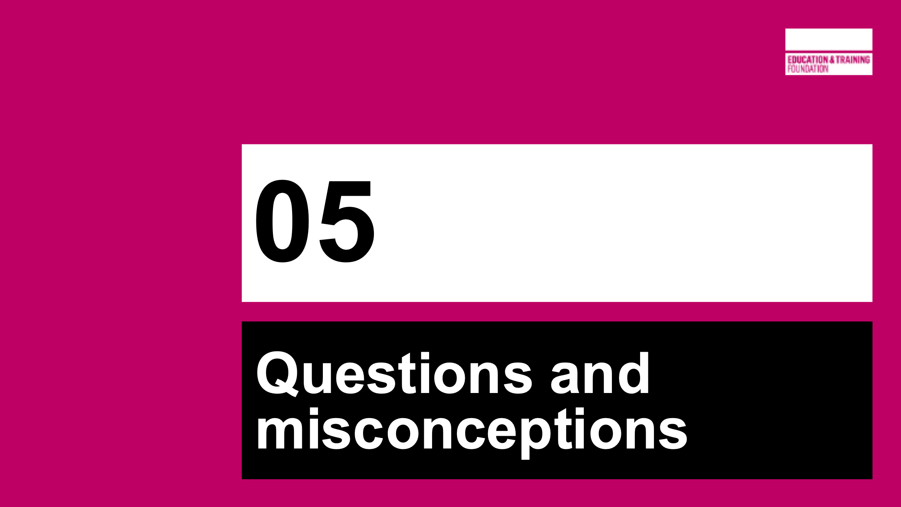 | SECTION 5  Questions and Misconceptions
2 mins  (117) | Slide 29 | Aim: To refresh memory of key concepts after coffee break | Version of earlier slide (not animated) – to refresh memory after coffee break.  This next section will explore how a selection of the Centres for Excellence in Maths have explored the concept of Responsive Teaching.
13 mins  (130) | Slide 30-32 | Aim: To introduce research from 3 CfEMs | Slide 30 - Lucy from Wilberforce Sixth Form College has given us an insight into their research this year.  https://youtu.be/9z9BpD-n-Pg (clicking sound icon on slide will go to YouTube where file is hosted.)  Main takeaway – using GCSE questions as diagnostics is efficient to see WHERE gaps in knowledge occur, but they do not highlight WHY they occur.  Wilberforce recognised that to highlight misconceptions a different approach was needed – they chose to look at “EEDI” and “DiagnosticQuestions.com” which have a bank of multiple choice questions. The choices of answer are chosen carefully to show any misconceptions that a student may have (more on this later!)  Slide 31 – Resource 2.5 as handout  Nelson and Colne College adapted a Questioning Matrix to aid teachers in their PRE-PLANNING of questions to tease out misconceptions. By using the sentence stems in the header row and column, questions can be framed at different levels to highlight misconceptions. Teachers can then adapt their teaching accordingly.  Explore this with participants.  Slide 32 - Shabana Raman from East Kent College Group explains their Entry (and exit) ticket approaches to identifying gaps and misconceptions.  https://youtu.be/4Djntj6ukYI (clicking video icon on slide will go to YouTube where file is hosted.)  Lovely analogy used by Shabana in the video about files being stored incorrectly.  Further quote from Shabana about the impact of responsive teaching in Functional Skills animates on click.
10 mins  (140) | Slide 33 | Aim: To explore multiple choice Diagnostic Questions | Many centres have used Diagnostic Questions like this example to great effect.  ACTIVITY – ask participants to answer this as though you are a Post-16 learner.  What mistakes could they make?  How are the responses designed to find misconceptions?  Insights provided by question author:  A We have 2 × 6 - 3² = 2 × 6 - 9 = 12 - 9 = 3.  B The student has squared (6-3).  C The student has squared at the end, rather than the beginning.  D The student has squared negative 3.  More DQs can be found by signing up (free) here: https://diagnosticquestions.com/  Authors of note: eedi, White Rose, AQA, Edexcel, OCR  There is also a link to DQs on the Module 2 Padlet.
15 mins  (155) | Slides 34-36 | Aim: To discuss case study of Leyton Sixth Form’s use of diagnostic questions in their planning | RESOURCE 2.6 HANDOUT  PD Lead to talk through this case study which is illustrated by slides 34, 35 and 36.  Slide 34 Jane from Leyton Sixth Form College shared with us the checks they are using in their maths lessons – also using a multiple-choice question approach. The slide shows an excerpt of a diagnostic assessment.  They used questions from “DiagnosticQuestions.com” and also wrote their own to ensure they were identifying the misconceptions linked to their Scheme of Learning and lesson structure. Students’ explanations of the choices they made are every bit as important as the choice itself. These help uncover misconceptions, and show that the answer is not just a guess.  Slide 35 zooms in on question one for participants to discuss. What misconceptions do the incorrect choices exemplify?  Discuss the misconceptions probed:  A – Added the x coordinates together and the y coordinates together  B – Incorrect negative number work  C – Correct answer  D – Fundamental misconception  Slide 36 RESOURCE 2.7 HANDOUT  Leyton also took the DQs a step further, asking the students to critique the reasons given for answers to multiple choice questions.  Talk through this with participants – what are the benefits here? More links and connections being made?  In Improving Learning in Mathematics (the blue box Standards Unit), Malcolm Swan encourages the working with Reasoning and Solutions as well as Evaluating Statements. These dovetail beautifully with Leyton’s work here.
 | 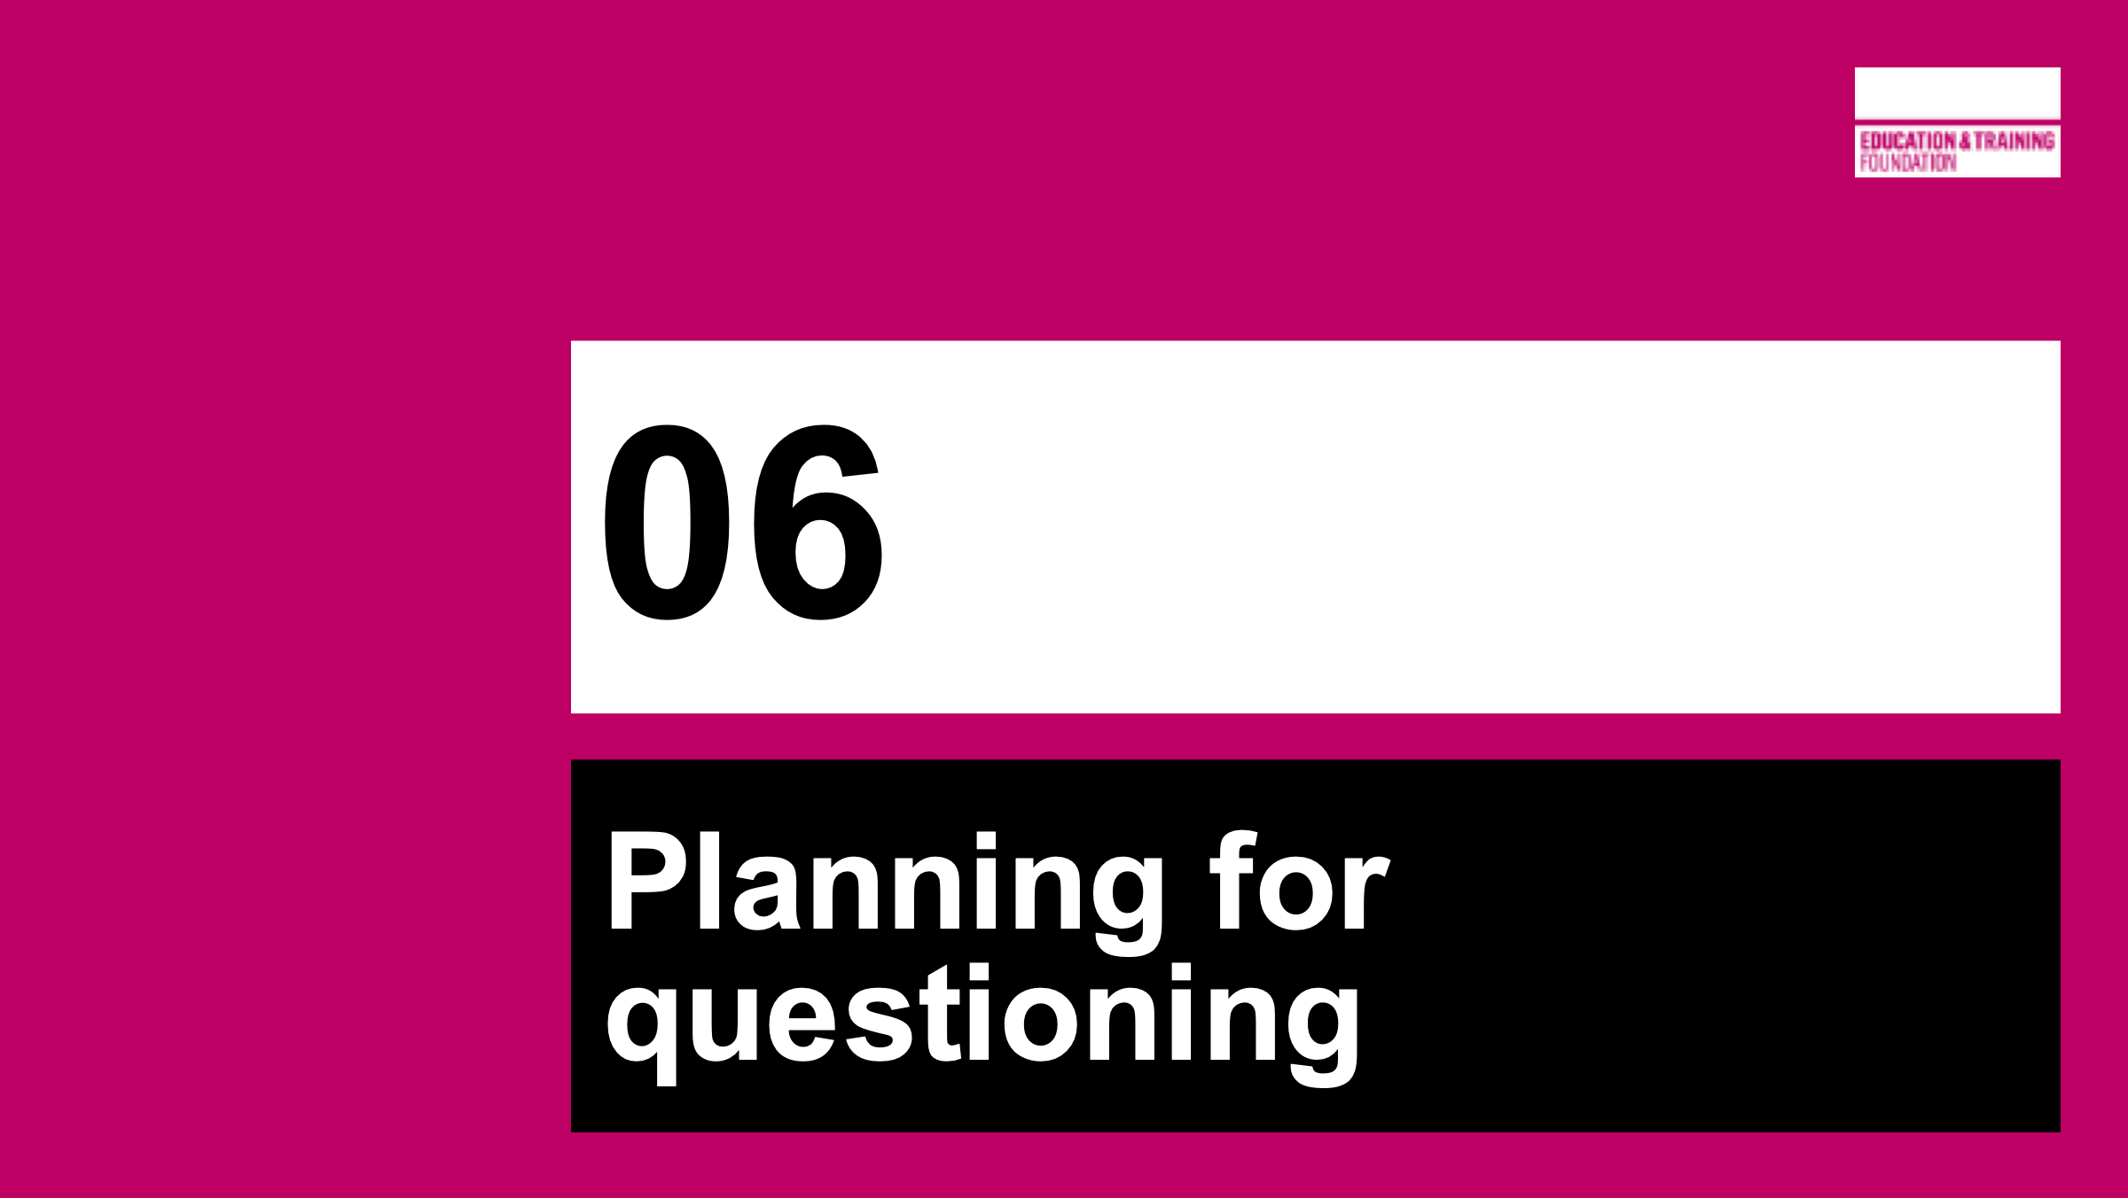 | SECTION 6  PLANNING FOR QUESTIONING
15 mins  (170) | Slides 38-39 | Aim: For groups to develop their own DQs in a chosen format for use with their own learners | Participants will use their diagrams from the earlier activity to formulate a diagnostic question.  They should draw from all types discussed – entry/exit, multiple choice, oral, adapted exam qs AND any others that they think will work.  The questioning techniques covered in the previous section highlight misconceptions in such a way as to be able to show the students exactly WHY they are getting the concept incorrect. This means that a teacher is enabling DELIBERATE RE-THINKING to help the student make new connections (whether as a whole class or an individual).  PD lead should circulate offering advice.  Each group will present their question/s to the cohort, inviting answers and discussion of the misconceptions tested.  There is room for this activity to be extended – more questions, change of topic etc as needed.
 |  | SECTION 7  NEXT STEPS
10 mins  (180) | Slides 41-44 | Aim: To set up gap tasks for session 3 | Slide 41 – invite participants to explore the DQs formulated in their own classrooms, and feedback next time  Slide 42 – Gap task 1: ask participants to complete this activity before next session – noting down the different ways they could find to solve the question  Slide 43 – Gap task 2: ask participants to watch the video of Jo boaler talking about Mathematical Connections: https://www.youtube.com/watch?v=7FE_8wGgw_M and make brief notes to discuss at the next session.  Slide 44 – Links to further CfEM resources and publications related to responsive teaching.
 |  | Close

