Brief overview of purpose and content of module | Logistics
The session explores the tools of bar models and ratio tables as an aid to understanding proportionality. It draws on participants' own experience, the research from Centres and wider literature.  This module demonstrate how models can be used successfully in a wide variety of topics.  The PRE-SESSION task for this module should be emailed to participants prior to session with sufficient time for completion.  ESSENTIAL – “Em, Finch and Gill” proportion question from a National Trials lesson, as introduced at the end of Module 2.  ESSENTIAL – YouTube video - https://www.youtube.com/watch?v=7FE_8wGgw_M | Room Layout  - Cabaret style  - Projector with accessible PC and/or laptop connection (with internet)  - Drywipe board  Materials Needed  - Flipchart sized paper and stand  - Marker pens  - Sticky putty, normal stationery (sticky notes, notepaper, pens)  - Mini-whiteboards  Course webpage  Course resources can be accessed from the CPD pages of the CfEM resources and evidence hub: https://www.et-foundation.co.uk/professional-development/maths-and-english/cfem/cfem-resources-and-evidence/cfem-professional-development/modular-course/  PowerPoint  Slides with yellow banners should be personalised by the PD Lead for their session and location. The yellow banners should then be removed.  Suggestion  Ask participants to bring internet enabled laptops or tablets. Arrange with the venue for wifi logins so that participants can access and explore the Padlet.

Time for session: 3 hours

Resource list and printing requirements
Notes:
- Updated files should have the date in their filenames. Each time you lead a module, check that you are using the latest resources. File content will be regularly reviewed and improved.
- Resources are numbered for ease of reference. First number is module number, second number is resource number. Resources are in no particular order.
- Check that all files and links will open and run on the computer you will be using when you lead a session. PowerPoint doesn't always work well if run on a version different from the one it was written in.
- Note: Resources 3.8 to 3.11 are exam papers, which must be downloaded from awarding body websites. Links for Pearson Edexcel are supplied, but papers can also be downloaded from other awarding body websites.

Resource number | Filename | Section in which it is used | Number to print | Printing essential, suggested or e-version only?
3.1 | Proportion question and YouTube video | Pre-session activity | 0 | On Padlet
3.2 | 3.2 Module 3 Presentation | All | A4, colour, 1 per participant. Printed as handout and stapled in top left hand corner | Essential
3.3 | 3.3 Module 3 Session Outline | All | 1 per trainer, stapled in top left hand corner | Suggested
3.4 | 3.4 Ratio Table Questions | Section 4 | A4, B&W, 1 per participant | Essential
3.5 | 3.5 Ratio Table Solutions | Section 4 | A4, B&W, 1 per 4 participants | Essential
3.6 | 3.6 Bar Model Questions | Section 5 | A4, B&W, 1 per participant | Essential
3.7 | 3.7 Bar Model Solutions | Section 5 | A4, B&W, 1 per 4 participants | Essential
3.8 | Edexcel FS Maths Level 1 Paper 2 Section A and B Question Paper  (Download: https://qualifications.pearson.com/content/dam/pdf/Functional-skills/Mathematics/2019/specification-and-sample-assessments/Functional_Skills_%20Maths_Level_1_Practice_Paper_2.zip) | Section 6 | A4, B&W, 1 per session, split into 2 halfway through paper | Essential
3.9 | Edexcel FS Maths Level 1 Paper 3 Section A and B Question Paper  (Download: https://qualifications.pearson.com/content/dam/pdf/Functional-skills/Mathematics/2019/specification-and-sample-assessments/Functional_Skills_%20Maths_Level_1_Practice_Paper_3.zip) | Section 6 | A4, B&W, 1 per session, split into 2 halfway through paper | Essential
3.10 | Edexcel GCSE Maths 1F – June 2019  (Download: https://qualifications.pearson.com/content/dam/pdf/GCSE/mathematics/2015/exam-materials/1MA1_1F_que_20190522.pdf) | Section 6 | A4, B&W, 1 per session, split into 2 halfway through paper | Essential
3.11 | Edexcel GCSE Maths 2F – June 2019  (Download: https://qualifications.pearson.com/content/dam/pdf/GCSE/mathematics/2015/exam-materials/1MA1_2F_que_20190607.pdf) | Section 6 | A4, B&W, 1 per session, split into 2 halfway through paper | Essential
3.12 | 3.12 Reflective log for Module 3 | All | A4, B&W, 1 per participant | Essential

Time (Elapsed time in brackets) | Slide number | Learning intention | Slide notes and additional information
Pre-course task |  | Aim: To introduce participants to the course to minimise the time spent on this during Module 3. | Make sure that teachers have the pre-course tasks at least a week before Module 3.
 |  |  | Registration and refreshments.
15 mins  (15) | 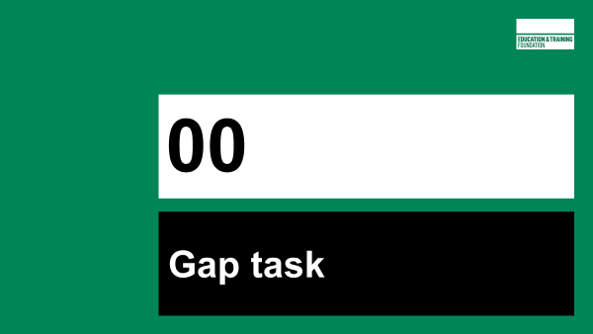  Slide 3 | Aim: To explore variety of methods for solving a question involving proportionality | Straight into a maths problem to start the session.  Participants will have prepared their own solutions prior to the session.  Participants show their working to one another on their tables.  Try to get a selection of different approaches and ask 3 or 4 participants to write their working on a whiteboard or flip chart.  Then ask each one to explain their approach.  𝐸 + 2𝐸 +3𝐸 = 60  6𝐸 = 60  𝐸 = $\frac{60}{6}$  𝐸 = 10  𝐹 = 20  𝐺 = 30  Others may do it using arithmetic, recognising 6 equal parts and doing 60 ÷ 6 = 10  Others may use a bar model, or other representations.
 | 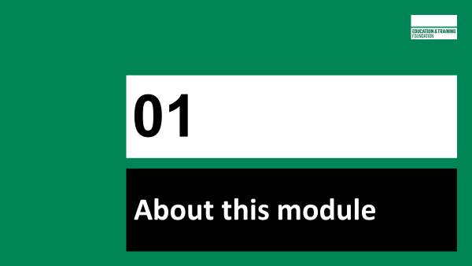
5 mins  (20) | Slides 5 - 8 | Aim: Housekeeping and overview of session | Introductions- name and college  Reflective Log - (briefly) somewhere to make short notes about items they can take away and use.  Course Padlet - contains all module resources and also suggested further reading. Module 3 Padlet will be unlocked at the end of the module, or earlier if PD Lead wishes.  You may also want to mention that the use of models can help reduce cognitive load and therefore reduce the amount of working memory that is used.  Please replace asterisks with timings specific to your session (and remove yellow banners)
 | 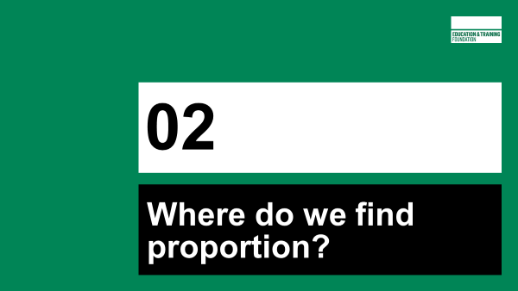
15 mins  (35) | Slide 10 |  | Connections video from gap task: ask participants what they thought of the video. Try to tease out that it’s about making connections and how it reduces the amount of working memory that is used.  Probe for the key concept that underpins all the topics explored in the video – i.e. they are based around proportional reasoning.
 | Slides 11 | Aim: Participants to appreciate how much of Level 1 and 2 maths is related to making sense of proportion. | Ask a quick question: what proportion of GCSE maths is proportion, ratio and rates of change? For Foundation Tier its 30%, but well above 50% when you look at other GCSE topic areas where it is present.  Do this as a show of hands. Suggest asking "Is it 15%, 20%, 25%, 30% 35% or 50%?
 | Slides 12 - 13 |  | Ask participants in pairs or on their tables to come up with misconceptions that students might have with ratio and proportion. Presenter circulates finding out what misconceptions’ participants come up with. Participants feedback their misconceptions to the whole group.  This is a list of the misconceptions that participants might come up. Are there any misconceptions that the group missed that you might want to highlight?  Presenter might mention some of the ideas below.  - Each of these misconceptions could make a lesson in its own right.  - Identifying misconceptions is key to planning for responsive teaching.  - Exposing and addressing misconceptions helps support learners’ understanding.,
 | Slides 14-16 | Aim: A provocative and contextualised question to elicit proportional thinking | ‘Whose statement would you prefer?’ is supposed to be a provocative question.  Looking at the information we have, it would be Kai.  Participants will hopefully say "You don’t know how long the statement was for" and "You don’t know if the rate is constant".  Circulate and see how participants have answered.  Now participants have more information, ask them to answer this in 2 different ways.  Ask them to consider which of their methods is the more formal or informal.
 | 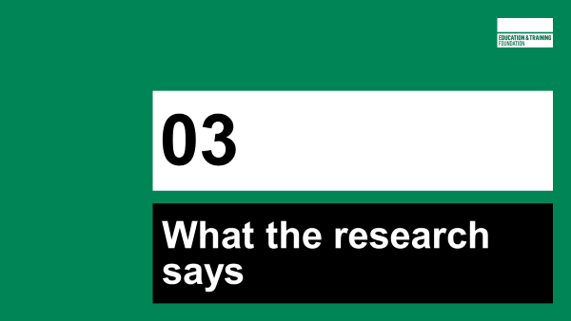
5 mins  (40) | Slides 18 - 20 | Aim: To communicate the research that exists for FE | Slide 18 This is a quote from ‘Investigating the impact of a Realistic Mathematics Education approach on achievement and attitudes in Post-16 GCSE resit classes’.  RME closely aligned with mastery.  Key messages to get across from this research:  - Ratio tables and bar models allow students to work more informally - they don’t need to remember multiple methods, thus reducing cognitive load  - Ratio tables and bar models can be used as models in a variety of contexts  - In RME, models are derived from the context. For example, if a ribbon is cut into equal lengths, the ribbon can be drawn as a bar and the model arises from the context. As students progress they can use bar models to represent other situations.  Slide 19 Example of a ratio table and bar model used with a reverse percentage question.  It is really shown as an example of what a ratio table and bar model are for those that might not have heard of them or used them.  Slide 20 Important to note that teachers need to practise and master new ideas. Students need to be supported in use of new models.  Action research from CfEM shows that models have an effect on all learners including grade 3s, but the greatest impact is on grade 1 and grade 2 students.
 | 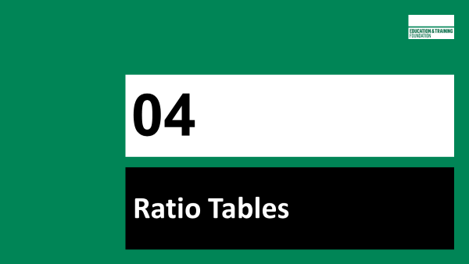 |  | NB – PD Leads can choose which order to cover Ratio Tables and Bar Models. It’s possible that ratio tables might be completed in less than 45 minutes, giving more time for bar models.
45 mins  (85) | Slides 23 - 36 | Aim: For participants to appreciate that investment in time using ratio table can be of benefit across a wide range of topics | Ask participants  Where do we find proportional reasoning in GCSE maths or functional maths?  In what topics does proportional reasoning occur, in addition to proportion, ratio and rates of change?  PD Lead to ask for quick fire responses. PD Lead to record responses on flip chart or whiteboard.  Play video and pause at 1 min 35 sec to compare the list of where Proportion is found and where Byron is saying ratio tables can be used in GCSE Maths and FSM.  Play video to the end.  Ask participants for their thoughts on the video.  Remember Byron is a teacher from one of the CfEMs. This gives credibility for using ratio tables with learners.  Download video in advance to avoid problems with streaming during the session.  Blueberry muffins - This question can be modelled on the PPT slides but is much more dynamic if you ask people to come up with their own approaches and model on a whiteboard as a whole group.  Starting with 12 and 108, where would you go from here?  People might divide by 2, 3, 4, 6 or 12.  There are many ways that a ratio table like this can be used.  The important thing is that students get to choose what they do.  They might divide by 2 and use 6 by adding 6 until they get to 18.  Lots of learners are able to do multiplication as repeated addition, i.e. 6 + 6 + 6 = 18. Though this is less efficient than 3 x 6, it will nevertheless enable learners to use what they know but help them progress to more efficient methods.  Slides 26 to 28 are hidden. They are not to be used with participants but might be an aid to understanding for PD Leads.  Milkshake  Participants answer this question individually using a ratio table and then their approaches are compared.  Slides 30 to 36 are hidden. They are not to be used with participants but might be an aid to understanding for PD leads.7
 | Slide 38 | Aim: To show examples of real-life students work in FE | Same question, same student, a different response before and after the student was introduced to ratio tables (Michael Lancaster, Harlow College). Ask participants to analyse where the student went wrong in the first example. "
 | Slides 39-40 | Aim: To summarise features and benefits of ratio tables and to direct to further reading about ratio tables | RESOURCE HANDOUTS 3.4 AND 3.5  Ratio tables generally work best if they are horizontal, as we read left to right. However, they may work better vertically for some learners.  Ratio tables reduce the load on working memory.  Ratio tables have many uses. Here are some. The list is not exhaustive:  - ratio  - multiplication & division (including long & short)  - speed, distance, time  - density  - rates  - proportion  - pie charts  - enlargement  - conversions  - equivalent fractions  - percentages  - best buy  - scale drawing  Further reading for ratio table:  https://rme.org.uk/getting-started/working-with-rme-materials-using-models/the-ratio-table/  https://thirdspacelearning.com/blog/ratio-table/  Interactive online ratio tables:  https://mathsbot.com/activities/missingFDPGrid  Utilise participants that have experience of ratio tables to support others.  Depending on the skills levels and experience of ratio tables you will get a variety of responses.
15 mins  (100) | Slide 41 | BREAK
 | 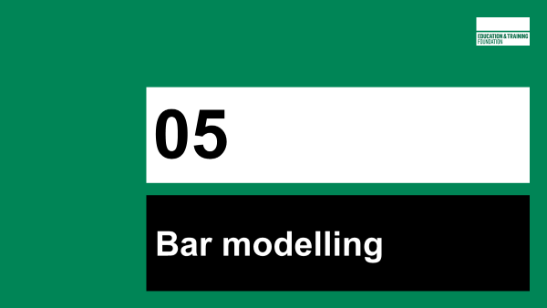
45 mins  (145) | Slides 43-49 | Aim: For participants to have a growing awareness of the flexibility of bar models from very easy questions to complex problems | Slide 43 Use this slide to demonstrate how a bar model can be used for a simple division problem and demonstrates how bar models can be used for all levels of calculation and problems – from basic to complex.  Slide 44 This slide shows the use of a bar model for simple multiplication.  Slide 45 This slide shows the use of a bar model for simple division.  Slide 46 First of two problems to solve using a bar model.  Bars animated to show thinking process. Answer 1:4:2  Slide 47 This slide shows how a bar model can make a complex question easily accessible through a visual representation.  Show the 4 questions without the bar models. Ask participants to work on questions for one minute. Then reveal the bar models. Ask participants to work on the questions using the bar model.  Stop participants working after about 2 minutes.  Ask participants which method of working they found easiest. Anticipate that they will see that the bar model visual representation will have made questions easier to answer. Participants may say that they did it algebraically and that having written $A=A, R=4A, U=2A$ makes it easier as you don’t have to draw anything. You could ask “Which method might learners find easiest and prefer?”  Allow participants time to have a go at completing the questions using bar modelling, then show the animations on this slide. They follow a structured and consistent way of bar modelling.  The activity is based on procedural variation. It is worth highlighting this to participants as the situation of the maths competition doesn’t alter, but the questions do alter slightly. Procedural variation can help learners to identify connections and structure.  The questions are intentionally in no order. When learners are tackling these questions it is fine for them to do them in any order.  Participants might comment that this context isn’t a realistic context. On the surface this looks like a realistic context. However, it isn’t really a believable context, it is a pseudo context as it is unlikely that Richard and Usha’s scores would be four times and twice April’s respectively.  The activity could easily draw out misconceptions. Drawing out misconceptions from the activity will enable teachers to respond to needs of individuals and the whole class.  Some misconceptions that might emerge:  - Richard’s score is 156 points. Learners might divide by 7 parts (all 3 competitors), rather than 4 parts (Richard’s share)  - Find the mean by dividing 7 parts by 3  - Median is 156. Richard is middle value on bar model and in written order in question.  - Mode is 156 or Richard as there are more bars on bar model and might be mistaken due to having similar appearance to a bar chart.  Slide 48 Allow participants time to struggle working on this using bar models  Slide 49 Here is one way that bar models could be used to solve this problem.  Ask for a volunteer to talk their way through the animation, giving clear explanations and reasoning.
 | Slides 50-52 | Aim: To show examples of real-life students work in FE | Examples of student work to discuss.
 | Slide 53-54 | Aim: To summarise about the benefits of using bar models in a range of contexts | Slide 53 Bar models may be used in a variety of situations, there isn’t one correct way or method.  Bar models can be used for many uses, and this reduces the load on working memory.  Bar models have many uses, here are some, though not exhaustive: (Anywhere where 2 or more quantities are in direct proportion)  - ratio  - addition & subtraction  - multiplication & division (including long & short)  - proportion  - conversions  - equivalent fractions  - fractions  - decimals  - percentages  - best buy  - solving equations  Further reading for bar models  https://rme.org.uk/getting-started/working-with-rme-materials-using-models/the-bar-model/  https://www.ncetm.org.uk/classroom-resources/ca-the-bar-model/  Interactive online bar models:  https://mathsbot.com/manipulatives/bar  Slide 54 Practice - Encourage participants to work in pairs.  Dependent on time, you may want to let participants continue.  You may want them to share on their tables and then share with the whole group.  Use your judgement on how participants have handled using bar models.  Ask participants how they think bar models would work with their learners.  Utilise participants that have experience of bar models to support others.
 | 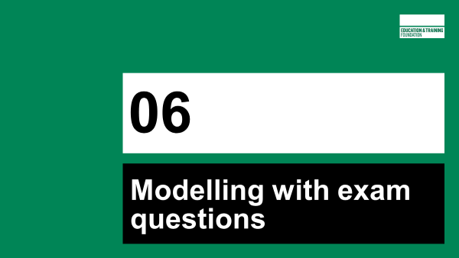
30 mins  (175) | Slide 56 | Aim: To investigate how ratio tables and bar models can be used with multiple topics | RESOURCE HANDOUTS 3.8 TO 3.11 (NB These must be downloaded from awarding body website)  Each group of 4 will choose to work with half of a GCSE paper or FS paper. Tell participants to identify questions where a ratio table/bar model could be used. They are NOT being asked to answer the question.  Aim here is for participants to see how ratio tables and bar models can be used in an exam paper.  If possible, use a visualiser to review this activity, so that participants can see which question is being reviewed.
 | 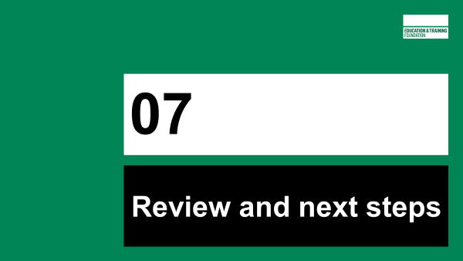
5 mins  (180) | Slides 58-61 | Aim: Time for participants to reflect on Mod 3 and look forward to Mod 4 | Slide 58: Participants will be at different stages of confidence and competence.  Participants may:  - want to hone their own skills before going public  - choose a class to work on questions on ratio tables  - decide that they are going to introduce bar models to their own team.  Slide 59-60: Introduce gap task to be completed before module 4.  Slide 61: Further resources from CfEM relating to visual models and representations

