Brief overview of purpose and content of module | Logistics
This module aims to familiarise teachers with a variety of manipulatives and to show the impact that their use can have in the GCSE resit classroom.  The PRE-SESSION task for this module should be emailed to participants prior to session with sufficient time for completion.  - ESSENTIAL: Read the following blog posts:  - https://www.et-foundation.co.uk/cfem/resit-mastery-leyton-sixth-form/  - https://www.et-foundation.co.uk/cfem/cfem-blog-the-focussed-15-at-grimsby-college/  A PDF version of the blog posts is also provided in the resources for this module.  - ESSENTIAL: Read the rationale for the CfEM scheme of work and browse the content. You can choose between:  - GCSE re-sit  - Functional Skills level 2  - Functional Skills level 1  Consider:  - What considerations have informed the scheme of work?  - How does this relate to the curriculum design approaches from gap task 1?  - How could you adapt this scheme of work for your teaching. | Room Layout  - Cabaret style  - Projector with accessible PC and/or laptop connection (with internet)  - Drywipe board  Materials Needed  - Flipchart sized paper and stand  - Marker pens  - Sticky putty, sticky notes, A4 notepaper, pens  Course webpage  Course resources can be accessed from the CPD pages of the CfEM resources and evidence hub: https://www.et-foundation.co.uk/professional-development/maths-and-english/cfem/cfem-resources-and-evidence/cfem-professional-development/modular-course/  PowerPoint  Slides with yellow banners should be personalised by the PD Lead for their session and location. The yellow banners should then be removed.  Suggestion  Ask participants to bring internet enabled laptops or tablets. Arrange with the venue for useable wifi logins so that participants can access and explore the Padlet.

Time for session: 3 hours

Resource list and printing requirements
Notes:
- Updated files should have the date in their filenames. Each time you lead a module, check that you are using the latest resources. File content will be regularly reviewed and improved.
- Resources are numbered for ease of reference. First number is module number, second number is resource number. Resources are in no particular order.
- Check that all files and links will open and run on the computer you will be using when you lead a session. PowerPoint doesn't always work well if run on a version different from the one it was written in..

Resource number | Filename | Section in which it is used | Number required | Printing essential, suggested or e-version only?
6.1 | Developing a Mastery Approach with GCSE Resit at Leyton Sixth Form College: https://www.et-foundation.co.uk/cfem/resit-mastery-leyton-sixth-form/  The ‘focused 15’ at Grimsby Institute  https://www.et-foundation.co.uk/cfem/cfem-blog-the-focussed-15-at-grimsby-college/ | Gap task | 0 | Online
6.2 | 6.2 Module 6 Presentation | All | A4, Colour, 1 per participant. Printed as handouts and stapled in top-left corner | Essential
6.3 | 6.3 Module 6 Session Outline | All | A4, B&W, 1 per TRAINER.  Stapled in top-left corner | Suggested
6.4 | 6.4 Blog Posts PDF | Section 3 | A4, Colour, 1 per participant. | Essential
6.5 | Mastery Scheme of Work: GCSE Maths re-sit | Section 3 | A4, B&W, 1 per participant specialising in GCSE re-sits | Essential if GCSE resit teachers in the group
6.6 | Mastery Scheme of Work: Functional Skills level 2 | Section 3 | A4, B&W, 1 per participant specialising in FS level 2 | Essential if FS level 2 teachers in the group
6.7 | Mastery Scheme of Work: Functional Skills level 1 | Section 3 | A4, B&W, 1 per participant specialising in FS level 1 | Essential if FS level 1 teachers in the group
6.8 | 6.8 Lesson Design Features handout | Section 6 | A4, B&W, 1 per participant. | Essential
6.9 | 6.9 Mastery lesson carousel | Section 6 | A3, B&W, 1 for each activity | Essential

6.10 | Speed  - Lesson slides  - Lesson plan  - Explore handout 2  - Pizza time scaffold | Section 6 | A4, B&W, 2-3 copies of each  Slides & lesson plans stapled in top-left corner | Select 4-6 of the lessons to use, depending on the size of your group  (Recommend one lesson per 3 attending)
6.11 | Arithmetic sequences  - Lesson slides  - Lesson plan  - Explore 2 template handout (A3)  - Explore 2 Handout (card) | Section 6 | A4, B&W, 3 copies of each  Slides & lesson plans stapled in top-left corner  - Explore 2 Template handout on A3  - Explore 2 Handout cut into cards
6.12 | Using ratios  - Lesson slides  - Lesson plan  - Bar models handout | Section 6 | A4, B&W, 3 copies of each  Slides & lesson plans stapled in top-left corner
6.13 | Percentages with a calculator  - Lesson slides  - Lesson plan  - Matching activity handout | Section 6 | A4, B&W, 3 copies of each  Slides & lesson plans stapled in top-left corner  - Matching activity handout single sided & cut into cards
6.14 | Understanding equations  - Lesson slides  - Lesson overview  - Completing descriptions handout | Section 6 | A4, B&W, 3 copies of each  Slides & lesson plans stapled in top-left corner
6.15 | Frequency charts and averages  - Lesson slides  - Lesson overview  - Representing data handout  - Cards | Section 6 | A4, B&W, 3 copies of each  Slides & lesson plans stapled in top-left corner  - Representing data handout - single sided  - Cut up cards
6.15 | 6.15 Reflective Log Module 6 | All | A4, B&W, 1 per participant | Essential

Time (Elapsed time in brackets) | Slide number | Learning intention | Slide notes and additional information
Gap task (for info) |  | Aim: To introduce participants to different approaches to curriculum design. | Make sure that teachers have the gap tasks at least a week before Module 6.
 | 
 | Slide 3 | Aim: Housekeeping | Slide 3 To be updated by deliverer of PD, and yellow parts removed.
 | 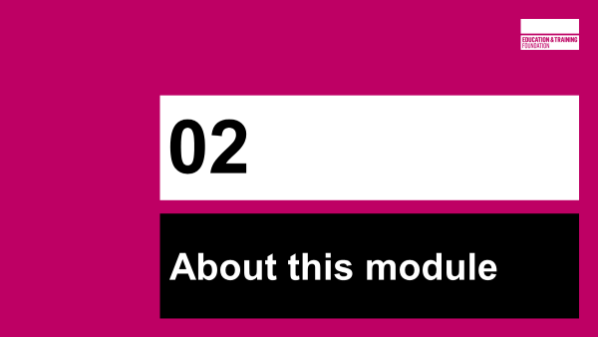
5 mins  (5) | Slides 5-7 |  | Slide 5 – Reminder of course structure  Slide 6 – Aims of session to be shared with participants  Slide 7 – Module contents
 | 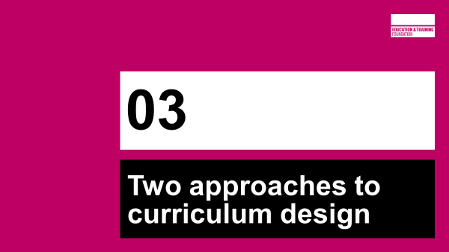
25 mins  (30) | Slides 9-16 | Aim: Participants to appreciate different aspects of curriculum design, highlighting similarities linking to the Key Principles and differences linking to context and professional judgement. | Slide 9 - Reinforcement of the three key questions and five key principles for mastery teaching.  Slide 10 - RESOURCE HANDOUT 6.4  Gap task 1 between modules 5 and 6 – to read 2 blog posts from CfEM centres taking different approaches to curriculum design.  Blog posts available as a pdf on padlet and at original source:  https://www.et-foundation.co.uk/cfem/resit-mastery-leyton-sixth-form/  https://www.et-foundation.co.uk/cfem/cfem-blog-the-focussed-15-at-grimsby-college/  Printouts should be available for groups to refer to during this task.  Slide 11 - Participants use sticky notes and flipchart paper to record similarities and differences in a Venn diagram.  (Extension - Use outside the rings for curriculum design elements that participants identify as not being covered in the blog posts.)  Display the Key Principles (Slide 9) whilst activity taking place  Slide 12&13 – Hidden slides, showing examples of possible answers – not exhaustive.  Images generated during PD Lead training.  Slide 14 - PD leads may wish to draw/make a ‘crowd sourced’ Venn diagram of similarities and differences on a board at the front of the room.  Draw out that the common points in each blog exemplify the Key Principles, with the differences showing adaptation for context/setting and professional judgement.  Slide 15 – RESOURCE HANDOUT 6.5, 6.6, 6.7  Gap task 2 – to read the rationale for the CfEM schemes of work.  Group participants according to which curriculum they wish to focus on:  - GCSE re-sit  - Functional skills level 2  - Functional skills level 1  Printouts of the relevant scheme of work should be available to each group.  Allow time for discussion of the three questions on the slide, then take feedback on Q1 and Q2.  Use slide 16 as appropriate to confirm the key points  Finish with a brief discussion of Q3. Prompt:  - Would they use the scheme of work as it is?  - If not, how would they use it or adapt it?  - What about the issue adaptation to the needs of learners? How could that be accommodated?
 | 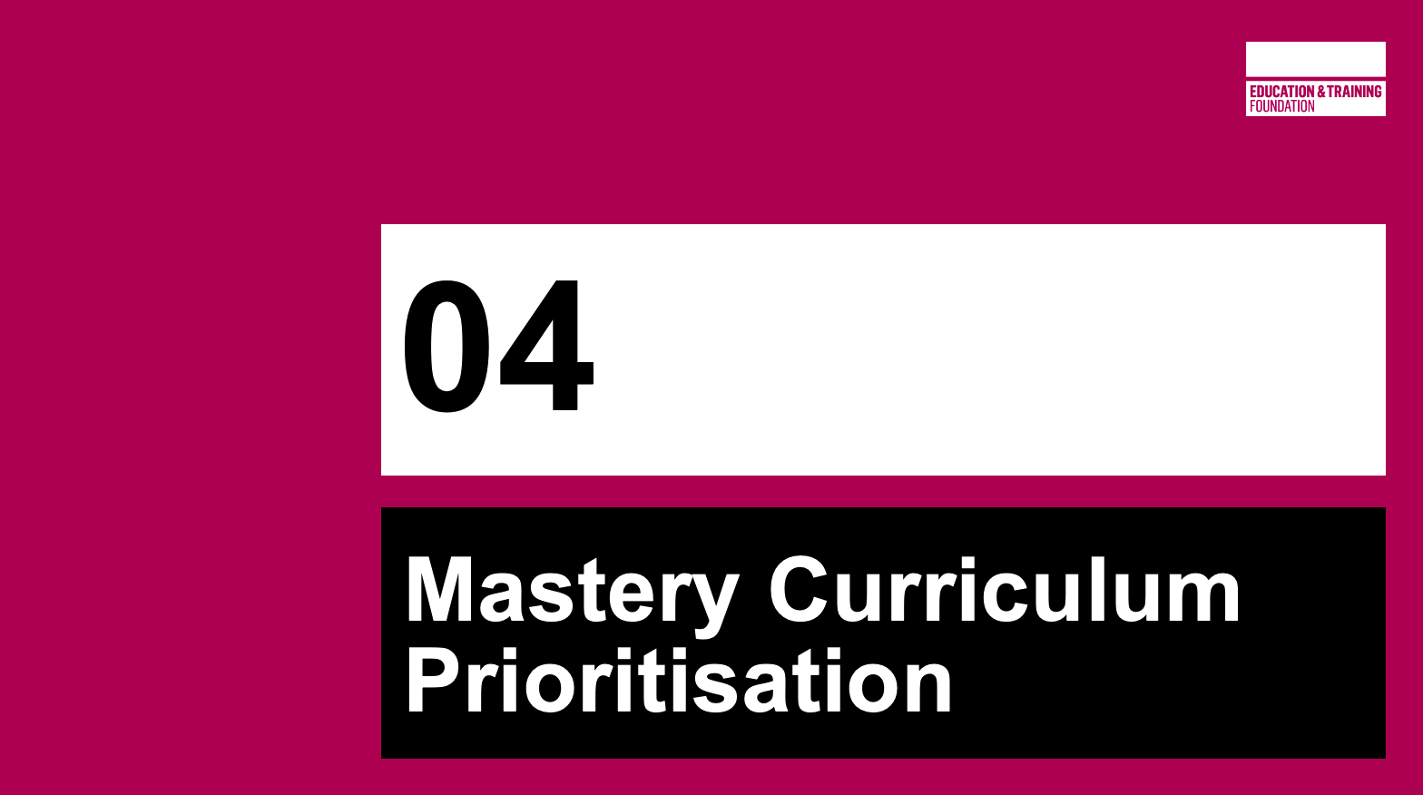
25 min  (55) | Slides 18-25 | Aim: To reflect upon curriculum prioritisation, and link this to a mastery approach | Slide 18 - These five key concepts are a particular focus of the CfEM scheme of work as being the most fundamental for Teaching for Mastery in FE Maths from both a qualification and a life-skills perspective.  Animated banner to prompt question: Why these concepts?  Participants will discuss the concepts in the next activity.  Slide 19 - Group task  PD Lead to assign a concept to each group.  Each group will decide why the concept is classified as ‘key’ from both a qualification and a life-skills perspective.  For example – What does ‘basic algebra’ mean?  Why is basic algebra needed for the Post-16 compulsory maths qualification, and why is it needed as a life skill?  This could mean Functional Skills, GCSE or both.
Each group will then put their case to the rest of the participants – but will have a two minute time limit in which to speak.
Use a timer for this.
The next 5 slides have banners for each concept that can be displayed as each group speaks.

Slide 20 – Working with and understanding number
Slide 21 – Multiplicative reasoning
Slide 22 – Fractions, decimals and percentages
Slide 23 – Basic algebra
Slide 24 – Measure (Area and Volume)

Slide 25 - The cases that each group puts forward are the type of conversations that should happen during curriculum and lesson design.
Everything included within a scheme of learning should be there for good reason (and help with answers to the perennial learner question: WHY AM I DOING THIS?)

Teams across the CfEM programme worked collaboratively to agree on the CfEM scheme of work – the next activity will mirror the processes they have been using to do that.
 | 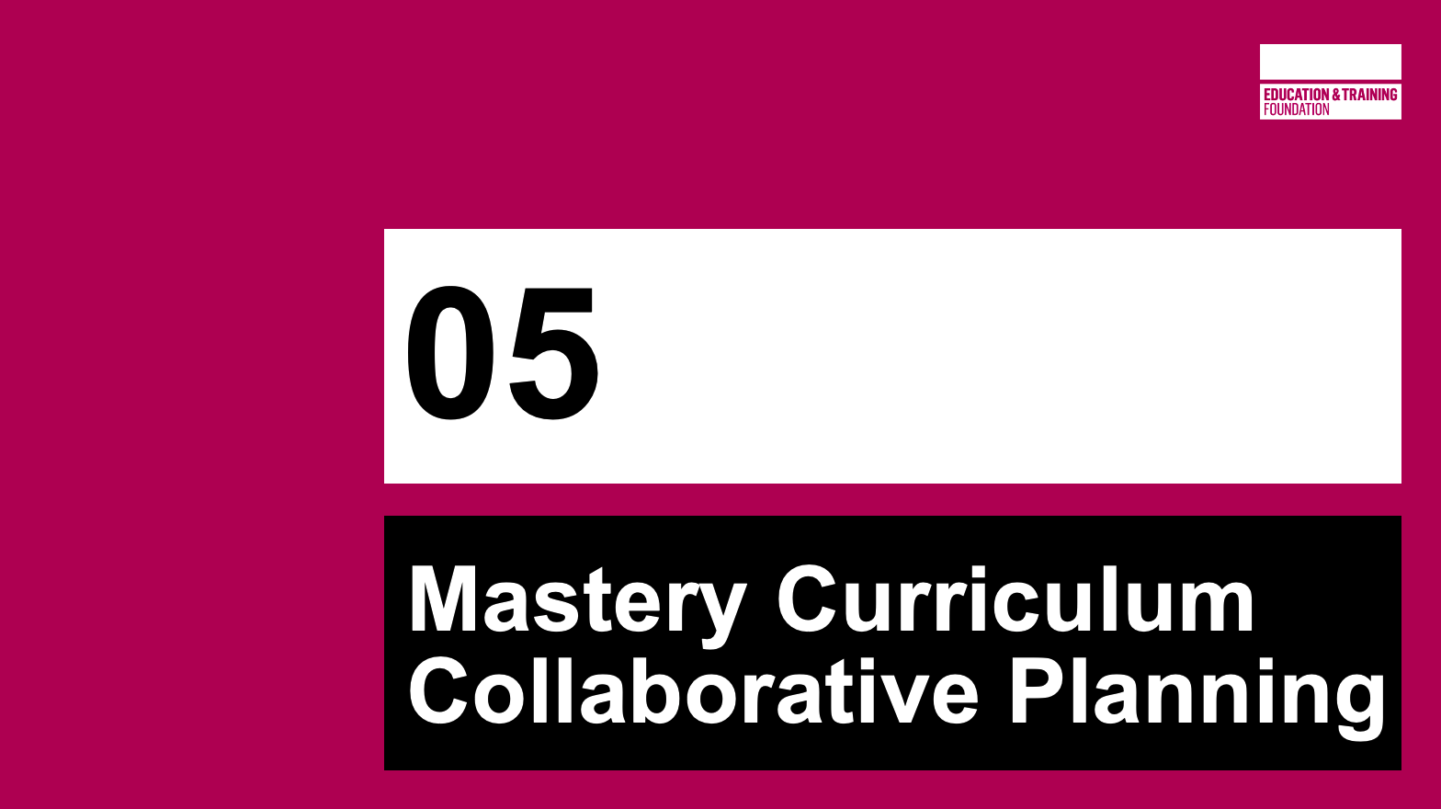
20 min  (75) | Slides 27-38 | Aim: to model a curriculum collaborative planning model which can be replicated with departments and teacher groups back ‘home’. | Slide 27 - Diagram animates to explain the process used by the CfEM programme in its curriculum planning as an example of an approach that can be taken.  Explain each once as they animate onto the screen.  Emphasis is on professional collaboration and looking for connections.  Groups are now going to go through a streamlined version of this process.  Slide 28 - This streamlined planning process activity only focuses on one key concept per group (the concept that the group advocated for in the previous section)  More realistic planning would include all concepts, but this activity will give a flavour of the conversations and methods that can be scaled up in a department meeting.  Each group should be provided with post-its and flipchart paper to facilitate this process.  Photographs can be taken and shared of the final products, but the process is what it most important here.  Slide 29 - Reminder of the concepts.  Slide 30 - Take feedback from the groups on how they found the process and how they can see it working on a larger scale.  How could they foster this approach in their own settings?  Would change need to happen first?
15 min  (90) |  | BREAK
 | 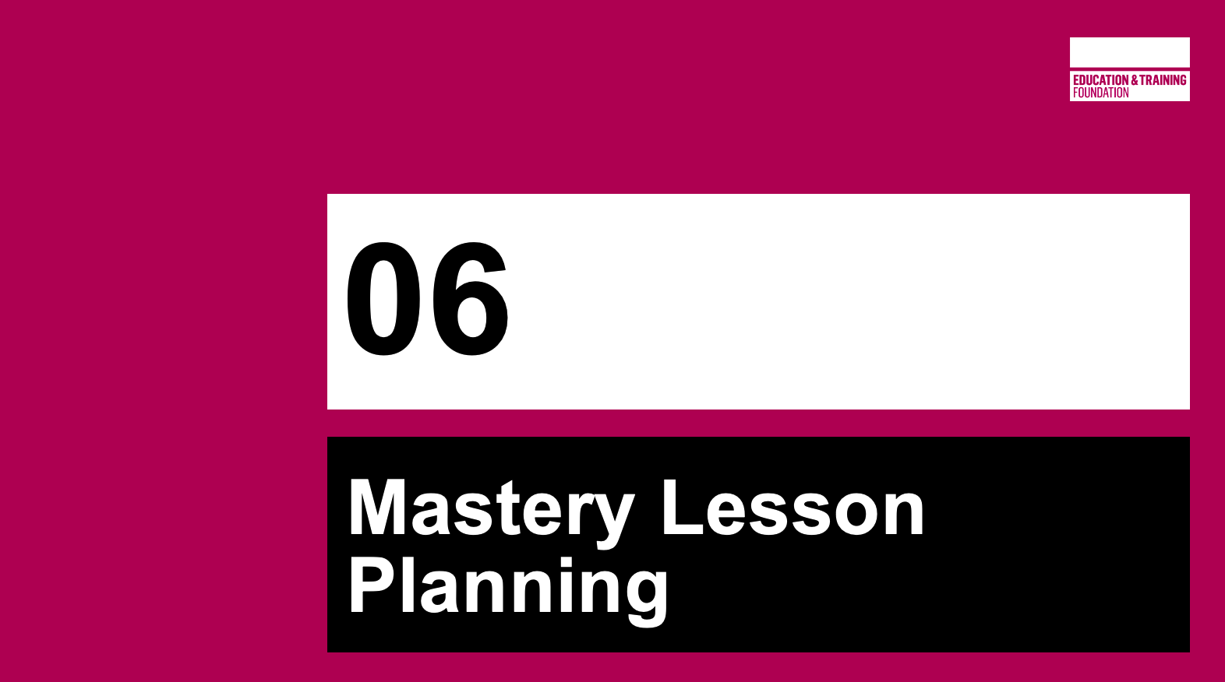
70 min  (160) | Slides 33-39 | Aim: Participants to discuss and examine the design features which exemplify the essence of a successful/effective FE maths lesson. | Slide 33 – explain how a set of ‘lesson design’ features were developed by the University of Nottingham, based on the 5 key principles of teaching for mastery, and how they informed research lessons used in the research conducted by the university as part of CfEM.  Point out links to the research lessons developed by the university and the research reports.  Slide 34 – explain how the same design features were adopted by CfEM teachers and used to develop the lessons which feature in the CfEM schemes of work – highlight the links to these.  Slide 35 - Introduce the Lesson Design Features.  All modules up to now have exemplified methods and techniques for teaching for mastery in FE maths. The design features bring these all together.  Slide is animated with the features coming in one by one.  Here is a brief exemplification of each design feature, if needed:  Identify and build on prior learning  •Provide opportunities to check & build on learners’ prior understanding of the topic  •Build on previous lessons in the scheme of learning  Use familiar contexts to introduce maths concepts  Where appropriate, use a context to introduce & develop the lesson which:  •Is relatable to 16-19 FE learners  •Can be used to highlight mathematical structure
Address common misconceptions
Expose & address misconceptions through activities that provoke reasoning or cognitive conflict (e.g. by sampling student thinking)

Use visual representations and/or manipulatives
Where possible, use models, representations & manipulatives to highlight mathematical structure
(e.g. bar model, ratio table, number line, algebra tiles, geoboards)

Connect different areas of maths where possible

Active engage learners through collaborative activities
Discussion which focuses on different methods & approaches (rather than checking answers)

Describe each element, using examples from your past workshops (some modules cover more than one element)
EG: mathematical structure- using manipulatives in Module 4
Foregrounding misconceptions – responsive teaching in Module 2
Call on participants for input during this.

Slide 36-37 – Activity: Mastery lesson carousel
RESOURCE HANDOUTS 6.8 to 6.15.

NOTE:
You should select in advance which of the lessons you wish to use for this activity – a minimum of 4 is recommended (or at least one lesson for every 3 participants). You may substitute other CfEM lessons if you wish, including those designed for Functional Skills, where appropriate to the group).

It is advisable to set out the lessons on tables during the break, if possible. Each table should contain lesson resources for one lesson, plus an A3 copy of 6.9 ‘Mastery lesson carousel’.

Slide 36 – Introduce the lessons and what is available on the tables.
Slide 37 - Explain the activity, and organise participants into groups of 3.

Allow up to an hour for this activity, with groups circulating to different tables to look at different lessons every 12-15 minutes. You might want to time this and ask groups to move to another table after a certain time, so that they are able to sample several different lessons.

Before moving to the next table, participants should write brief feedback on handout 6.9 for the next group to read – who then add their feedback and so on.

Slide 38 - After about an hour on the carousel of lessons, bring the group together again to discuss the activity and gather summative feedback. Use the three questions shown to guide a whole group discussion.

Slide 39 – highlight other websites where similar types of lesson can be explored and downloaded.

 | 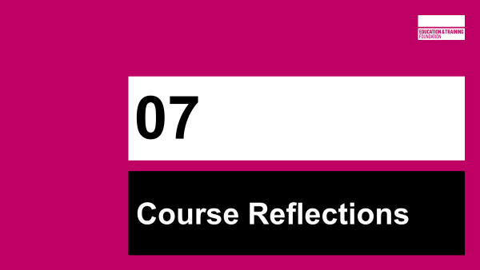
15 mins  (175) | Slides 41-44 |  | Slide 41 - Time to round everything off nicely.  Go through what’s been achieved since module 1 (Next slide has an image from each module which can be used during recap)  Allow each group collaborative time to reflect on their journey through the modules.  Prompts:  What have you achieved?  What has had most impact?  What do you want to develop further?  What’s next?  Slide 42 – Visual reminder of each module.  Slide 43 – Reflection prompts for display during discussion:  What have you achieved?  What has had most impact?  What do you want to develop further?  Image – Microsoft365 Stock Image  Slide 44 - Reflect on what has been achieved since module 1 - this is the question displayed in that first module.  What approaches have been developed which mean this prediction was correct?  Slide 45 - One final activity.  Invite participants to scan the QR code, or visit the url https://www.futureme.org/ (no sign up needed, but a verification email will be sent to agree to receive the message).  The website allows you to send your future self a message!  Set the date for 3 months from now.  What do you hope to achieved by then?  If you don’t quite get there, the message will serve as memory jog.

 | 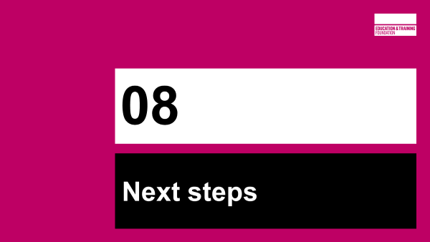
5 min  (180) | Slides 46-48 |  | Slide 47 – Reminder about course materials and CfEM Resources and Evidence Hub  Slide 48 – Thank you and final question

